RED LAKE COUNTY CENTRAL SCHOOLS
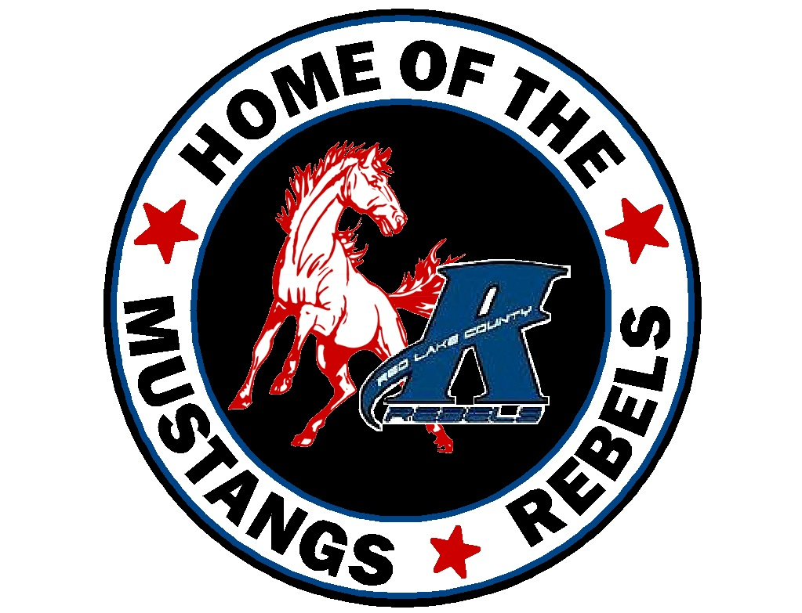

ISD #2906
RLCC High School Oklee 218-796-5136
RLCC Elementary Plummer 218-465-4222

James Guetter Andrew Fougner Randall Pederson

Superintendent Elementary Principal H.S. Principal

RLCC Triangular Wrestling Meet
Tuesday, January 19

Pre-Competition Timeline

- Weigh in’s take place at home site.

- All teams and spectators arrive on the East side of RLCC HS. Door #1 201 Governor St. S

- BCLB arrive approximately 4:30. F-B arrive approximately 5:15

- BCLB and RLCC Spectators arrive between 5:00 and 5:15

- F-B spectators arrive between 5:45 and 6:00 p.m.

- $5.00 per spectator. Exact change please as “drop bucket” will be used for payment. No change made.

- Skin Check at 4:20 for RLCC, 4:30-4:45 for BCLB and 5:15-5:30 for F-B

- 5:29 p.m. National Anthem (no team introductions)

Competition Schedule (approximate)

  - 5:30 p.m. Dual #1 BCLB vs. RLCC
  - 6:15 p.m. Dual #2 BCLB vs. FB
  - 7:00 p.m. Dual #3 RLCC vs. FB

Pods

- BCLB pod will be in RLCC’s wrestling room. Doors can be closed and athletes can dress in there if they don’t come already dressed. No locker room available.

- RLCC pod will be in the RLCC boy’s locker room

- F-B pod will be in the RLCC girl’s locker room

- Teams arrive at East Front doors of RLCC Door #1. This is 201 Governor St. Your drivers have probably been at that door before for drop-off.

- RLCC personnel will be ready to show you to your team pod. BCLB will be in the RLCC wrestling room and F-B will be in the RLCC GBB locker room.

Team benches

- For dual #1 at 5:30, RLCC team bench will be next to the stage, BCLB team bench will be on the east wall of the gym opposite the stage. BCLB team bench will stay there for both duals.

- After dual #1 the competition mat will be sanitized and the RLCC team bench will be sanitized. RLCC team will retire to the locker room. F-B will take over the team bench area directly in front of the stage and will stay there for both of their duals.

- After dual #2, the mat will be sanitized and the BCLB team bench will be sanitized. RLCC will take over that team bench, on the east wall opposite the stage, for dual #3 against F-B.

Spectators

- 2 spectators per participant. Each team in the dual gets 1 bleacher. Spectator list sent to sgunderson@rlcc.k12.mn.us by 1:00 p.m. day of match. Roster sent by Monday afternoon to kmelin@rlcc.k12.mn.us

- We have 2 sets of bleachers. We have 16 spots for 2 people each totaling 32. Keep this in mind, only 16 sets of 2 will fit in those bleachers. If you have more than 16 “participants” you will have to make choices as we can only seat 32 in your section of bleachers. Sorry!

- Dual #1: BCLB bleachers will be adjacent to BCLB team bench. They will stay there for both duals.
RLCC bleachers will be adjacent to RLCC Team bench nearest the stage.

- F-B spectators upon arrival will be seated at tables in the multi-purpose gym until being asked to come in for their first dual.

- After dual #1 RLCC parents will go to the stage. The bleachers will be sanitized and then F-B spectators will be seated.

- After dual #2, BCLB spectators will immediately clear the building. The bleachers will be sanitized and then the RLCC spectators will be seated. F-B spectators will remain in their bleachers.

Streaming

All 3 duals will be streamed via Garden Valley TV. All Garden Valley cable and/or internet customers will be able to access the competition on the RLCC channel 35

Here is GVTV information for “non-customers”. For $5.00 anyone with wifi can watch both duals. We’ve also now fully launched our live-stream functionality on our website at https://www.gvtel.com/video/livestream/ . This allows members and non-members to watch these games from a computer, tablet, or phone. Access for subscribers of a GVT service (phone, internet, cellular, GVTV) is included at no additional charge. Non-members can purchase access to the live stream; $5 for a 30 day access or $20 for an annual access. All paid subscriptions will support the school and local content channels.

